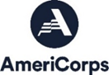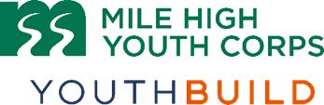

**YouthBuild Health and Wellness   
Corpsmember**

**Position Description:**

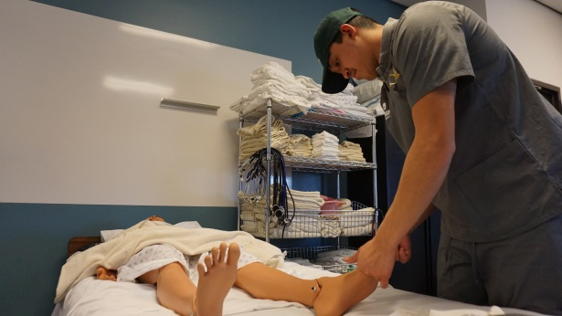YouthBuild participants (Corpsmembers) engage in intensive training divided between time in a health and wellness training program and service site and time spent in the classroom earning a GED or High School Equivalency diploma. Corpsmembers develop health and wellness skills while providing a minimum of 300 hours of service to the community in a health and wellness related position, set and achieve further educational goals and engage in leadership development, civic engagement, and career readiness and post-secondary preparation activities. Start date for the program is November 2023. Final start dates, schedules, and program format are subject to change. This position reports to the YouthBuild Field Coordinator: Health and Wellness.

**Corpsmembers EARN:**

* **Biweekly stipend**: Corpsmembers earn $1,075.00 (before taxes) every two weeks for an average of 32 hours a week. Raises and bonuses may be granted based on performance.
* **AmeriCorps Education Award**: Earn a $1,459.26 education award upon successful completion of the term (300 hours of service). This award can be used to pay tuition for college, trade schools, or certificate programs.

**Program Timeline:**

Corpsmembers will be enrolled in the YouthBuild Program until academic and placement goals are met, approximately 6-10 months.

* Corpsmembers will alternate between classroom [High School Equivalency & Arapahoe Community College (ACC) nurse aid classes] and service site days. Nurse aide class tentatively starts in February.
* Monday-Thursday 8 a.m. – 3:30 p.m., Fridays 8 a.m. – 12 p.m., Schedule may vary depending on projects.
* Program continues with 12 months of placement and follow-up activities following completion of program.

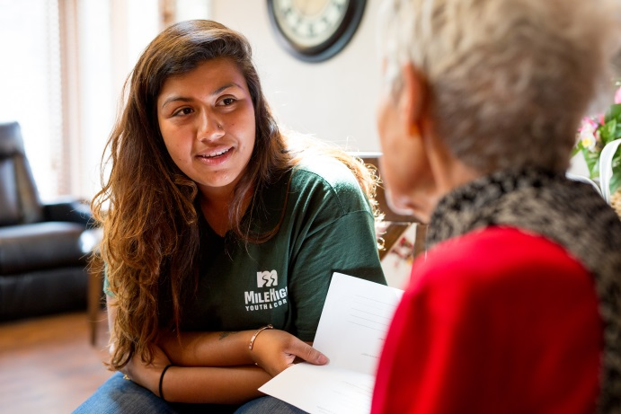

**Corpsmembers SERVE:**

* **In Health and Wellness Organizations**: Serve on a crew with other young adults in a health and wellness related position in the Denver Metro area. Activities may include educating the public on public health issues, helping low-income individuals and families access healthcare and related wellness services, and assisting seniors in an adult day program with daily tasks. Corpsmembers will serve alongside health staff and professionals to become familiar with health related instruments, vocabulary and methods.
* **Community**: Corpsmembers will participate in service projects with local nonprofits

**Corpsmembers RECEIVE:**

* **Education:** Fully participate in a GED or High School Equivalency program, as well as attend classes at a local

community college to earn your Certificate in Nurse Aide. Also participate in healthy lifestyles workshops, leadership development, and service-learning activities.

* **Trainings/Certifications**: First Aid/CPR, Certificate in Nurse Aide, hands-on technical training related to the health and wellness field, and other advanced trainings as applicable.
* **Career Readiness:** Career exploration, resume development, and networking with employers, apprenticeship, and union opportunities.
* **Post- Secondary/College Resources:** Develop skills and explore options for college including FAFSA completion, financial aid and enrollment support, scheduled campus visits, preparation workshops, etc.
* **Health Insurance**: May be eligible for health insurance the 1st of the month after serving at MHYC for sixty days serving 30+ hours a week.  Members are responsible for a portion of their health insurance premium monthly.

**Corpsmembers LEAD:**

* **Corpsmembers** serve as role models and promote volunteerism and service to the community across the agency.
* **Leadership Opportunities** include the possibility of serving on the Leadership Council, taking lead roles in the classroom and on the service site, and attending the Conference of Young Leaders in Washington, D.C. Corpsmembers also have the opportunity to provide direct programmatic input.

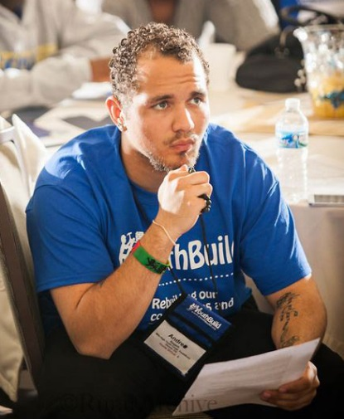**Qualifications:**

* Between 18-24 years old. Must turn 18 by November 28, 2022.
* Eligible for enrollment in AmeriCorps as a US Citizen, National, or Lawful Permanent Resident. Documentation will be required on the first day.
* Committed to earning a high school equivalency diploma.
* Desire to make a positive change in your life.
* Willingness to engage in assigned health and wellness related service. Must be physically capable of health and wellness field tasks, including, but not limited to: able to lift 50 lbs., squat, reach, crawl, stand for long periods of time, provide updated vaccination records, engage with community members from a variety of backgrounds and abilities, serving 4-8 hours per day.
* Able to commit to the entire term of service and willingness to enroll in a college level course.
* Desire to become involved in your community and increase your leadership skills.
* Able to be on time and maintain high levels of attendance.
* Actively participate as part of a team, show respect to others, and have a positive attitude.
* Committed to developing professional skills for long-term success.

*MHYC is committed to hiring candidates with unique backgrounds and perspectives. If you are interested in this job but are concerned that you do not meet all of the requirements or possess all of the necessary skills, or that prior convictions or your background might disqualify you, we encourage you to submit an application anyway.*

**Requirements:**

* Pre-service background-check required; this position has recurring access to vulnerable populations.
* Must follow MHYC and AmeriCorps Member Service Agreement policies and guidelines, including refraining from prohibited activities as listed in the agreement.
* Must be able to provide eligibility documentation, which may include proof of income and other documents.
* MHYC’s Community Health Partners have COVID-19 vaccination requirements. Individuals must submit proof of full vaccination, by their service start. MHYC can support applicants in this process during the hiring.

****To Apply:** Visit our website at [**www.milehighyouthcorps.org**](http://www.milehighyouthcorps.org)and click “Apply Now”.

Questions? Email [youthjobs@mhyc.net](mailto:youthjobs@mhyc.net) or call/text 303-946-1775.

*Mile High Youth Corps (MHYC) is an Equal Opportunity Employer. MHYC is committed to diversity in principle and practice, both in the community at large and within the organization.  We are, therefore, committed to having our internal operations and employment practices administered on a non-discriminating basis inclusive of, but not limited to, race, religion, color, socio-economic status, gender, age, sexual orientation, military or veteran status, physical or mental disability, marital status, or national origin. Every effort shall be made to grant reasonable accommodation for qualified people with disabilities to participate in this AmeriCorps program. MHYC’s YouthBuild program receives 48% ($1,114,987) of its funding from the Department of Labor.*